VIRAL FUSION
NEW INSERT — WHAT IF?
EDITOR TEMPLATE FOR JEETU

PLACEMENT — LOCK THIS BEFORE THE STRATEGY MAP
Insert this slide immediately after SLIDE 33 — THE BLUEPRINT and immediately before the strategy-map / guest-sequence reveal (THE PODCAST BECOMES THE STRATEGY).
Purpose: Slide 33 explains the architecture. This insert explains the experiment: the podcast is the mechanism used to begin assembling that architecture in real time. The strategy map then proves how each conversation adds capability.
FINAL CONTENT STATUS
RECOMMENDATION: FINAL / READY TO LOCK.
The copy below has been tightened for impact. The key improvement is credibility: we do not claim a podcast itself passes laws. We say the podcast convenes the people, evidence, technology and commitments that can begin lawful action.

NEW SLIDE — WHAT IF?
CAN A PODCAST BECOME AN EXECUTION ENGINE?
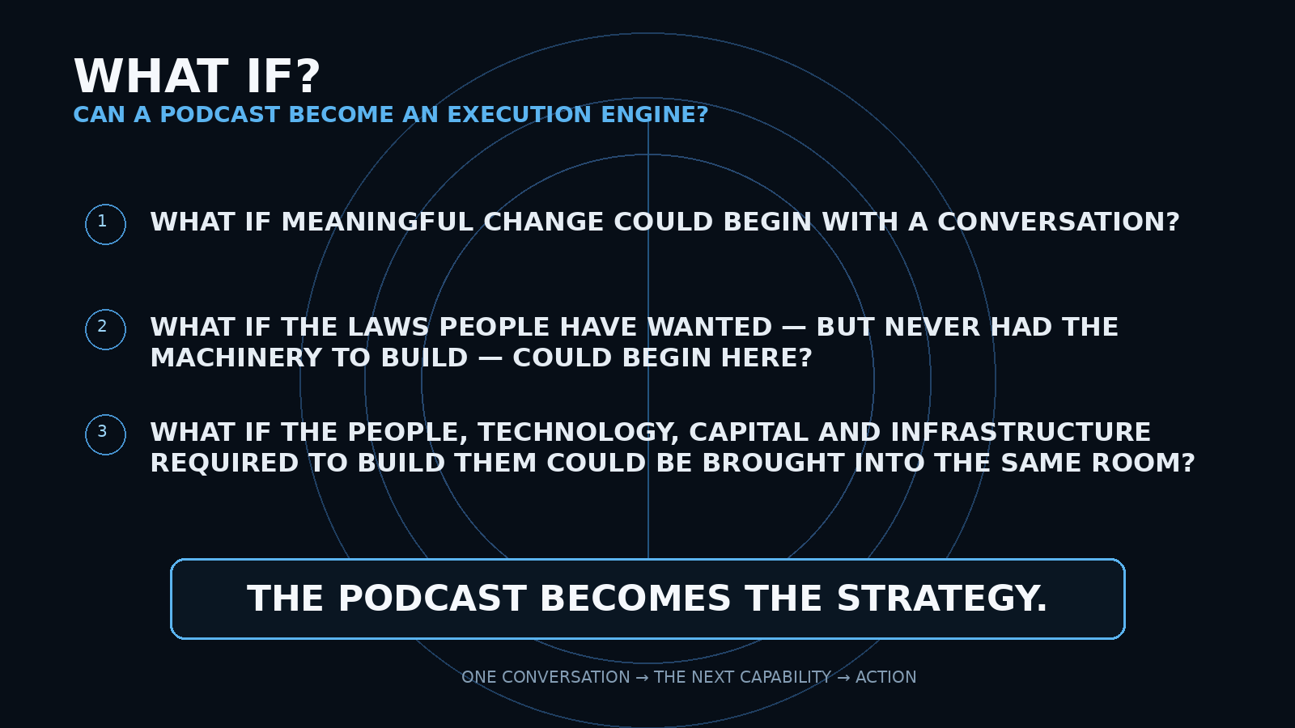
ON-SCREEN BUILD
• WHAT IF MEANINGFUL CHANGE COULD BEGIN WITH A CONVERSATION?
• WHAT IF THE LAWS PEOPLE HAVE WANTED — BUT NEVER HAD THE MACHINERY TO BUILD — COULD BEGIN HERE?
• WHAT IF THE PEOPLE, TECHNOLOGY, CAPITAL AND INFRASTRUCTURE REQUIRED TO BUILD THEM COULD BE BROUGHT INTO THE SAME ROOM?
• FINAL REVEAL: THE PODCAST BECOMES THE STRATEGY.

VOICEOVER — FINAL TIGHTENED VERSION
[GEORGE] (Quiet, personal. Let the question feel bigger than the medium.)
What if meaningful change doesn't begin inside government?
What if it begins here—
with a conversation?

What if the laws people have wanted—
but never had the machinery to build—
could begin with the right people in one room?

What if the technologies capable of improving people's lives—
could be challenged—
understood—
and given a lawful pathway forward?

What if one conversation could unlock the next person—
the next capability—
the next commitment?
[NARRATOR] (Measured. Ground the ambition in reality.)
A podcast cannot pass a law.
It cannot cast a citizen's vote.
And it should never replace the institutions responsible for either.

But it can do something extraordinarily powerful.

It can convene.
Expose.
Challenge.
Connect.
And create commitments that did not exist before the microphones turned on.
[GEORGE] (Build. This is the thesis.)
So this is the experiment.

Not:
"Can we make a successful podcast?"

But:

"Can a podcast become an execution engine?"

Can every conversation leave something behind—
knowledge—
relationships—
technology—
capital—
legislation—
infrastructure—
or a commitment to take the next step?

And if it can—
how far can one conversation compound into the next?
[TITLE REVEAL — NO VOICEOVER]
THE PODCAST BECOMES THE STRATEGY

EDITOR TIMING + MOTION
TARGET DURATION: approximately 60–80 seconds.
TIMING | EDITOR ACTION
0:00–0:05 | Open on near-black. Show only WHAT IF? Keep the rest of the slide hidden.
0:05–0:18 | On George's first question, reveal Question 1. Keep movement minimal; this is intrigue, not spectacle.
0:18–0:33 | Reveal Question 2. A faint line or pulse can extend from the first question toward the second, suggesting consequence.
0:33–0:46 | Reveal Question 3. The visual should now imply that people + technology + capital + infrastructure are converging around the conversation.
0:46–0:58 | As the narrator grounds the premise ('A podcast cannot pass a law...'), slightly dim the three questions. Do not add new visual claims.
0:58–1:10 | As narrator says convene / expose / challenge / connect, use restrained single-word pulses or short connection lines. Avoid icons unless they are subtle.
1:10–1:20 | On George's 'Can a podcast become an execution engine?' bring the final statement into full prominence.
FINAL | Cut to black for ~0.5–1.0 sec, then reveal THE PODCAST BECOMES THE STRATEGY. No voiceover on the title reveal. Immediately begin the strategy-map slide.
CRITICAL EDITOR NOTES
• Do not make this slide feel like a podcast advertisement. It is a thesis about convening power.
• Do not show guest names yet. The next strategy-map slide earns that reveal.
• Do not imply the podcast itself legislates, votes, or overrides lawful institutions.
• The emotional progression is: QUESTION → POSSIBILITY → REALITY CHECK → EXECUTION ENGINE.
• Keep the screen clean. The words are the creative. Motion should make the questions feel like they are converging into one thesis.
• On the final reveal, let silence do the work.

HOW THIS FITS THE EXISTING DECK
STAGE | AUDIENCE TAKEAWAY
SLIDE 33 — THE BLUEPRINT | Here is the architecture.
NEW INSERT — WHAT IF? | Here is the experiment.
THE PODCAST BECOMES THE STRATEGY | Here is the mechanism.
STRATEGY MAP / GUEST SEQUENCE | Watch the architecture assemble.
THE BLUEPRINT, NOW IN MOTION | Look at what those conversations created.
THE MISSING VARIABLE — VELOCITY | What changes the scale?
THE ACCELERATION LAYER — WHY MUSK? | Who has a technology flywheel capable of accelerating it?
CALLBACK FOR THE END OF THE DECK
Do not repeat this entire slide later. After California produces a measurable civic outcome, call back to it in one short beat:
[NARRATOR] We began with a question: could meaningful change begin with a podcast? By this point, the answer is no longer measured in views. It is measured in what the conversations produced.
Then show: PEOPLE → CAPABILITY → LEGISLATION → PARTICIPATION → OUTCOMES.
This gives the presentation a circular payoff: the podcast begins as a question and ends as evidence.

